|  |
| --- |
| EPAM Systems, RD Dep. |
| MTN.BI.08 ETL and SQL Review |

|  |  |  |  |  |  |
| --- | --- | --- | --- | --- | --- |
| REVISION HISTORY | | | | | |
| Ver. | Description of Change | Author | Date | Approved | |
| Name | Effective Date |
| 1.0 | Initial status | [Kiryl Bucha](mailto:Kiryl_Bucha@epam.com) | 12-JAN-2012 |  |  |
| 2.0 | Updated in accordance with renewed content | [Elias Nema](mailto:Elias_Nema@epam.com) | 20-JAN-2014 |  |  |
| 3.0 | Report | Aksana_Kuratnik | 20-NOV-2017 |  |  |

Contents

1. CREATE Storage Objects 3

2. Generate Test Data in Storage Layers 3

3. SQL*Plus 3

# CREATE Storage Objects

Format Physical Objects of your Business Model according to the templates.

Task Results:

Creation a directory (Shared folder – Aksana_Kuratnik):

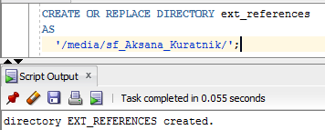

Creation of users for every layer

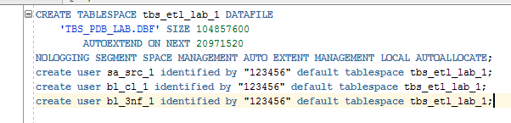



Giving Grants for users

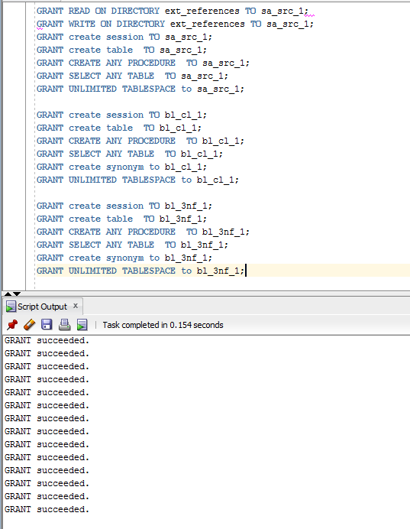

Creation of external tables:

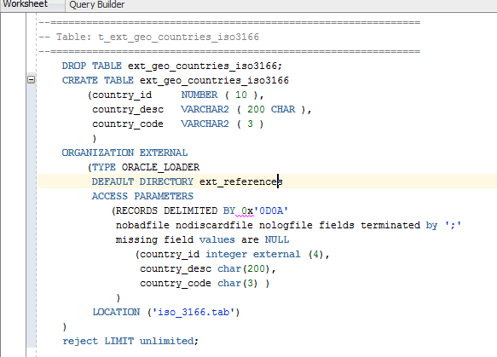

Creation of cl tables

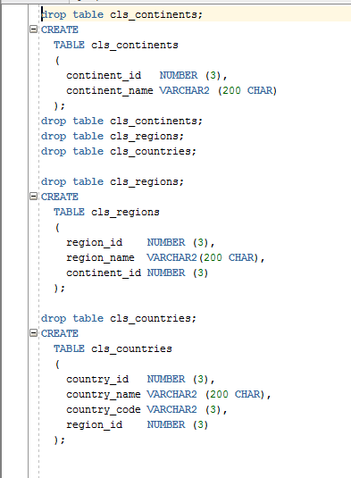

Creation of wrk tables:

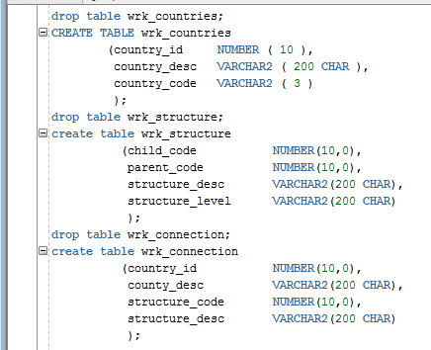

Creation of ce tables

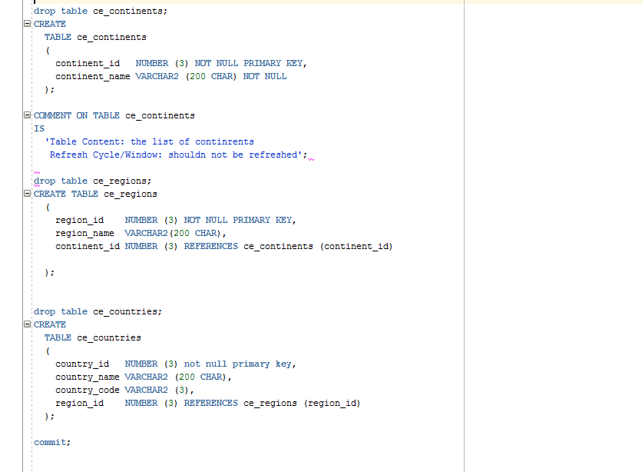

Data Scheme:

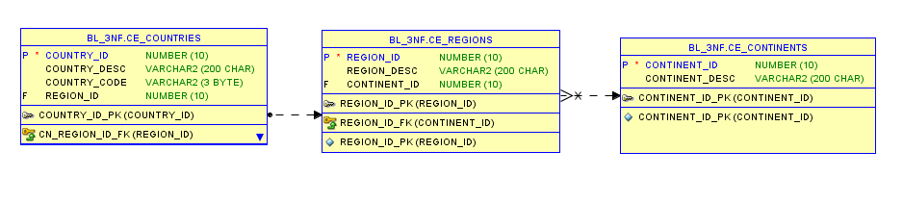

Create scripts for objects:

* Scripts put on Git
* Storage Layers Objects

# Generate Test Data in Storage Layers (загрузка данных в 3нф)

Proceed with loading of Locations data into the normalized level.

Insert to wrk:

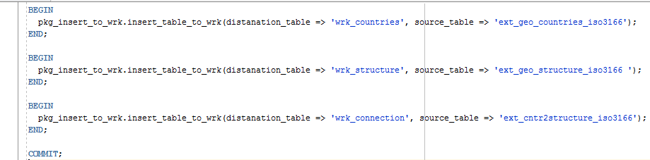

Insert to bl:

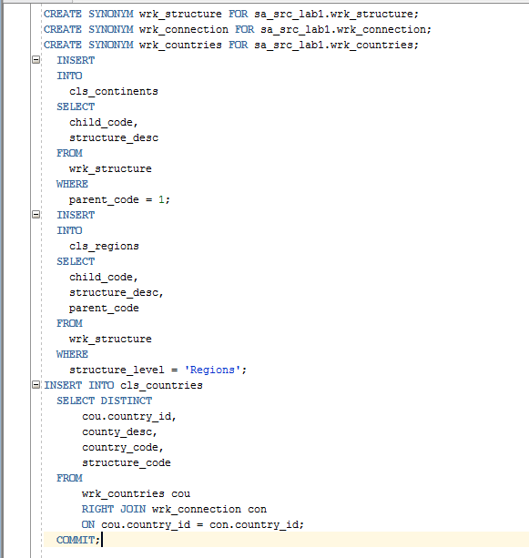

Insert to ce tables:

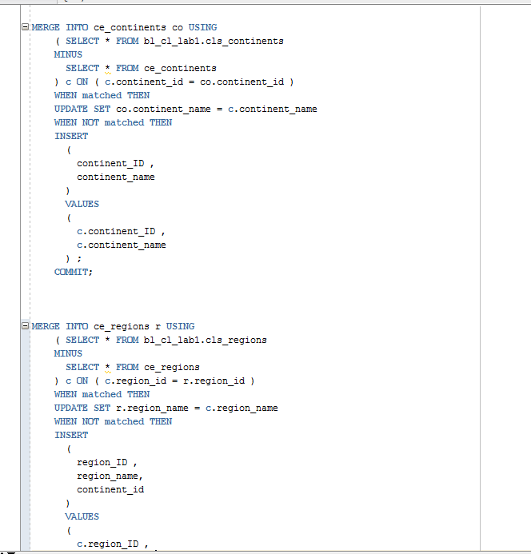

Task Results:

* Scripts put on Git
* Storage Layers Objects test data select screenshots

# SQL*Plus (сделать несколько селектов, посмотреть execution plan и записываем это в файл)

Connect to a database via SQL*Plus client and do next steps:

* Show execution plans in SQL*Plans
* Set timing on
* Run script
* Save data to file

Task Results:

* Put screenshots on Git.

Connect to SQLPlus from the terminal:



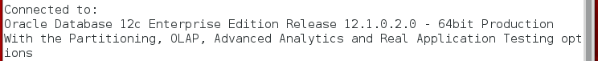

Create Execution Plan:

